Yacht-see!
Island Hopping in the Caribbean – IntimacyTravel Style
by
Kita and Gary de Sesa

According to WikiAnswers “roughly 34 million passengers take a cruise holiday each year, spending upwards of US $60 billion annually.” Yes, a lot of people love to cruise on their vacation. But the key phrase here is “a lot of people,” which for intimacytravel.com, raises a red flag. We have nothing against cruising, but cruising with hundreds or thousands of other passengers is not our idea of intimacy. So if you love to cruise and still want the intimacy, what do you do? You rent your own boat, of course!

We had occasion to be invited to a destination event in St. Thomas aboard a friends’ yacht, and it was there that we discovered the possibilities, pleasures and intimacy of island-hopping aboard a private boat.

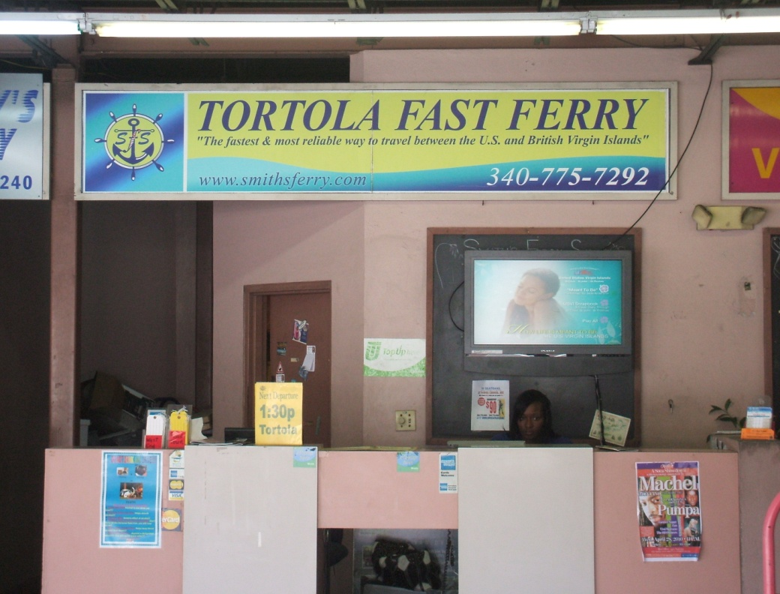
We took an easy non-stop flight from New York to Charlotte Amalie, St. Thomas in the US Virgin Islands. From there it was only a few minutes by Taxi to the very unassuming ferry dock, where we purchased a Fast Ferry ticket to Soper’s Hole Marina on the island of Tortola in the British Virgin Islands (BVI).
- Travel Tip: As you can see from the photo, the phone number is 340-775-7292 and the wesite address is www.smithsferry.com
- Travel Tip: Even though you officially don’t need a passport to travel to St. Thomas, you will need a passport to Tortola and other non-US Territories.
While we waited for the ferry, we went upstairs to the Petite Pump Room, an indoor/outdoor restaurant and had a delightful lunch overlooking Charlotte Amalie Harbor.

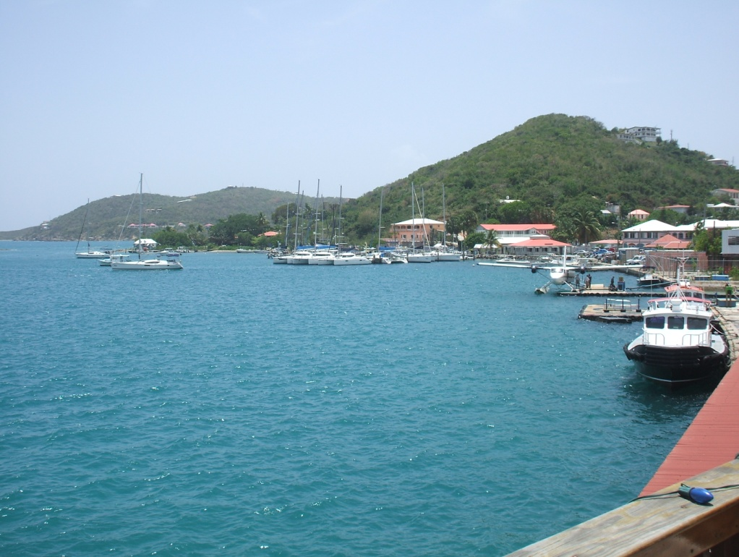

The Fast Ferry not only transports you physically, but psychologically, by combining local flavor with the sights, sounds and smells of the Caribbean. The sea air is cleansing and every so often its mist will grace you with a gentle welcoming “kiss.” In a half hour you are at Soper’s Hole Marina, Tortola where you disembark and go through Her Majesty’s customs.
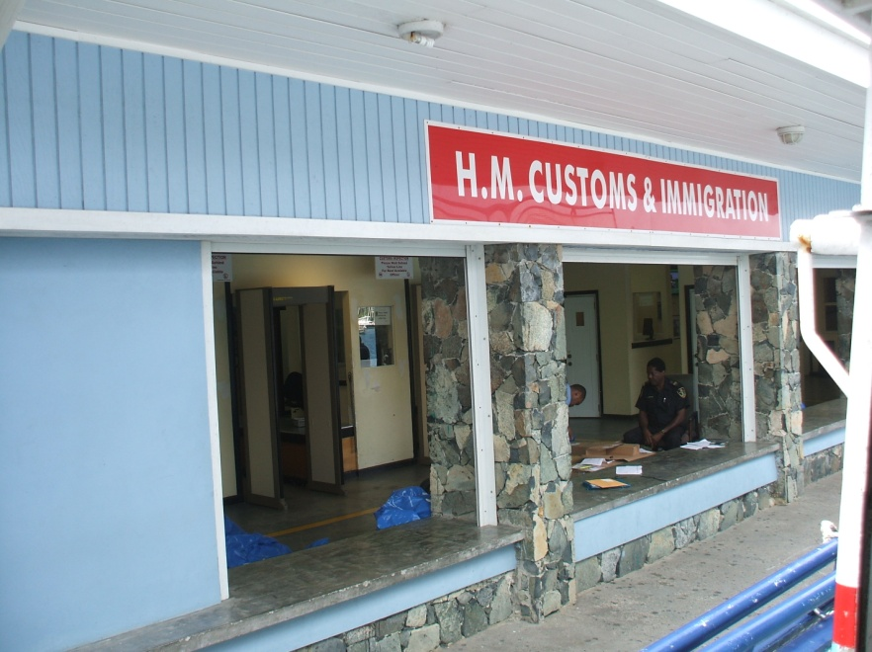

A short walk later we were at a primitive little doc, where we were met by our yacht’s tender, tied to a dock across the water at Frenchman's Cay (pronounced 'key').

We boarded the yacht, got acclimated, settled in to our cabin, had some refreshments and hors d'œuvres on board, then took our tender and docked at the Jolly Roger Restaurant for dinner. This casual atmosphere eatery with good food is located on the water's edge at the entrance of Soper's Hole at the West End of Tortola. The JR (as it is affectionately known) has been called the “heartbeat of the West End.”

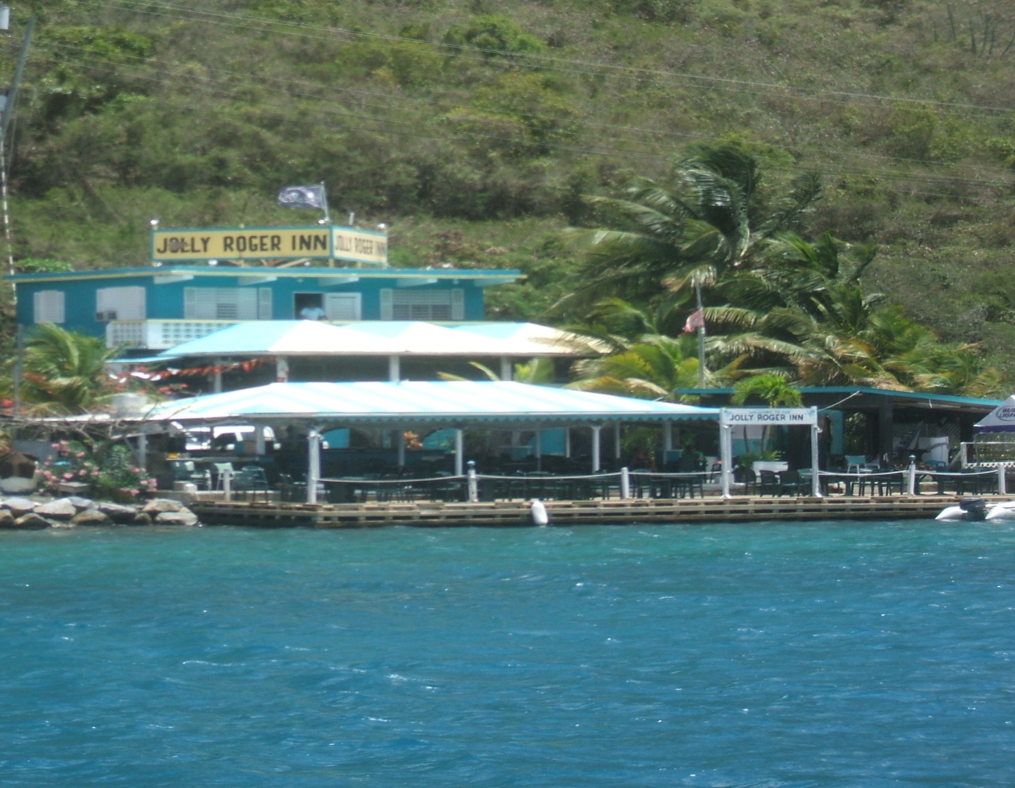

The following morning we set out to Peter Island Resort and Spa on, you guessed it, Peter Island.

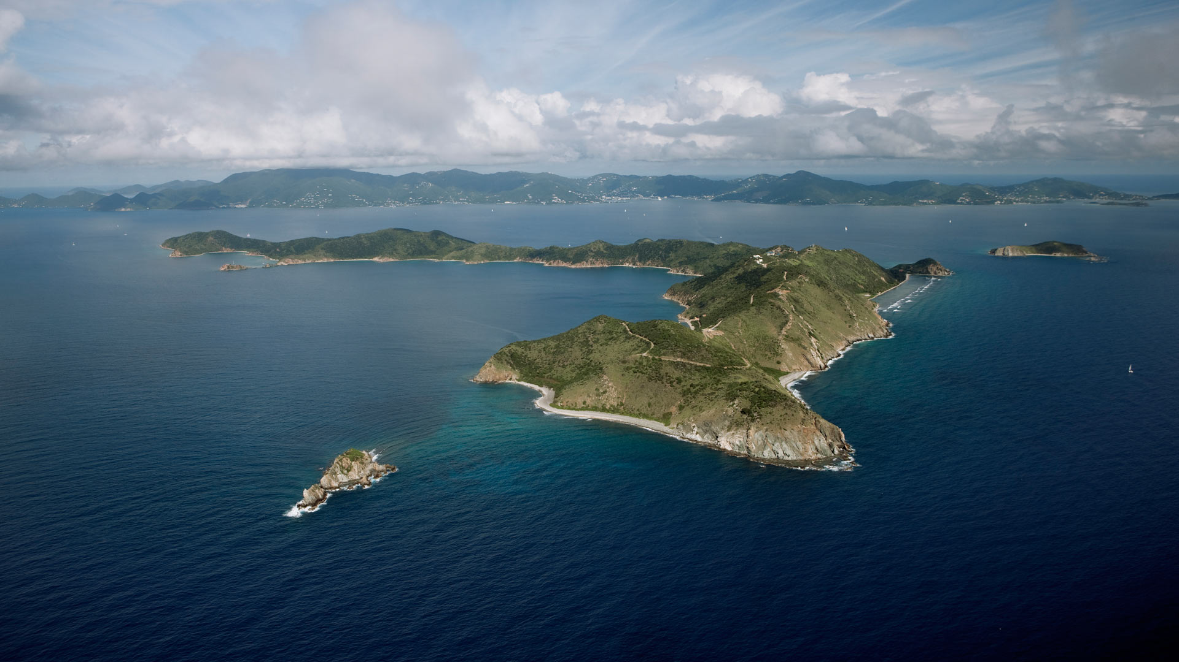

This is a classy resort with a magnificent beach and pool. They also have a relaxing recreation room with large screen TV, two computers and a pool table.
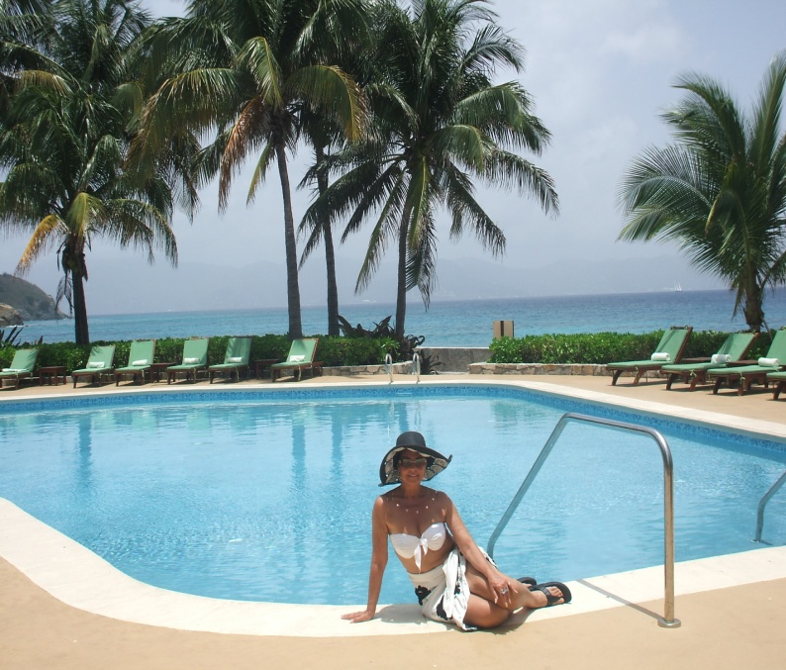
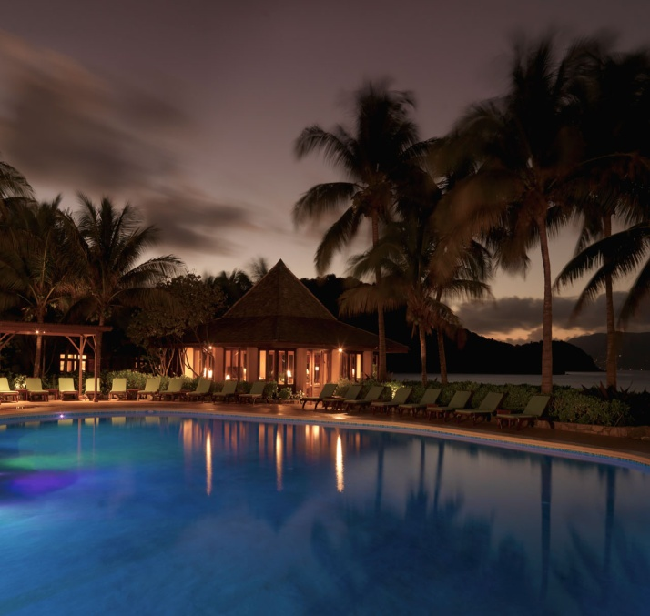
Whether day or night, Peter Island is a feast for the eyes and food for the soul. And speaking of food, the Tradewinds Restaurant, with its large picture windows overlooking Sir Francis Drake Channel and Tortola, offers opportunity for intimate dining with many corner tables for two. Try to reserve table #11 or #40.

We also dined at Deadman’s Beach Bar & Grill, which was having a grand buffet dinner and were festively entertained by a live band and colorful dancers on long stilts.

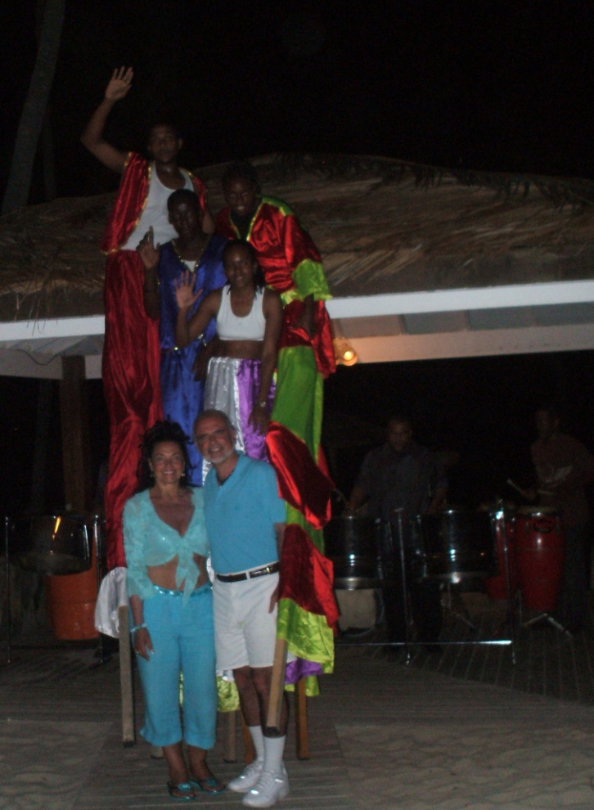

An alternative to the Peter Island Resort you can travel from Tortola to Scrub Island Resort, reportedly a very boat-friendly establishment.
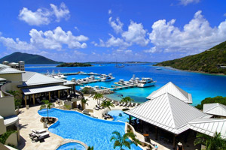
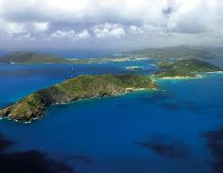

We enjoyed the facilities at Peter Island Resort for two days, then preceded on to Virgin Gorda and The Bitter End Yacht club.

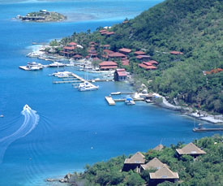

The facilities at The Bitter End Yacht Club are more modest and casual than Peter Island Resort, but some like it just for that reason. The Bitter End refers to it as “barefoot elegance.” We preferred Peter Island Resort, its beach and pool. Even though Peter Island is larger, we didn’t find it less intimate – just the opposite, in fact. Because it was larger, we felt that we had more secluded space to ourselves, especially on the beach.

From the Bitter End, we walked on a wonderful nature path to Biras Creek Resort. We have never been disappointed with a Relais & Chateau resort and this was no exception. Like other Relais we have visited, Biras Creek is a sophisticated, up-scale resort providing luxury and privacy. “Do Not Disturb” signs are replaced with discreetly placed stones or ropes draped across your entrance way. Everything is focused to preserve the natural beauty of the island. Even the outdoor pool deck seems to co-exist with the sea.

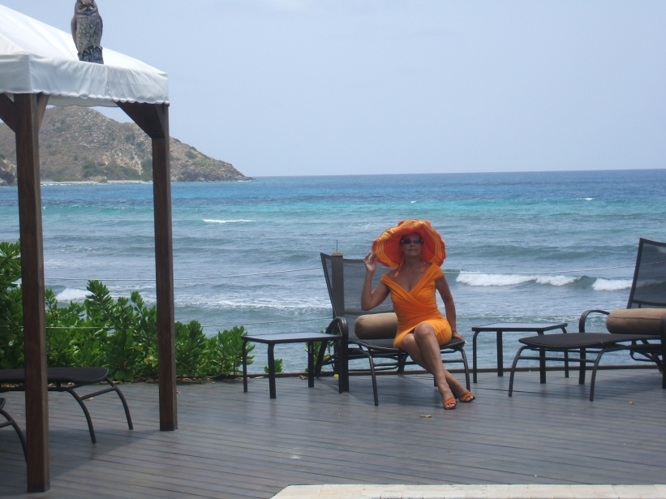

The next day we took the yacht’s tender to a private beach around back of Prickly Pear Island looking out onto Necker Island which belongs to Richard Branson, Chairman of Virgin Group which includes Virgin Atlantic Airlines and Virgin Records.

We packed a picnic lunch and had one of the most unique experiences. Ever see one of those commercials where a couple has an entire island to themselves and wished that you could be that couple? Well, you can! It was just us and a few goats that wandered by. The water and beach were perfection. We made “friends” with a school of very friendly small semi-transparent silvery fish who hung around us while we waded in the water. We were even able to have some fun feeding them with some crumbs we made from our chips. They loved it!

From our private island we could see Saba Rock in the distance, the smallest occupied island in the British Virgin Islands. There you will find Saba Rock Resort and Restaurant.

So if you are not invited aboard a friend’s yacht, how do you make all this come true? Well, when we returned to Soper’s hole we decided to find out. It wasn’t easy to miss as it was quite well advertised.

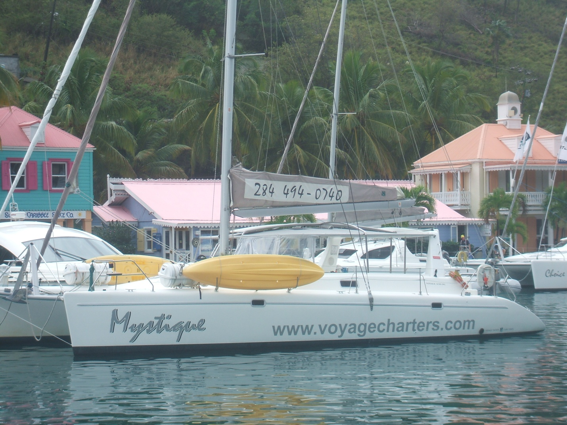
We went aboard several of their South-African made catamarans of different sizes. They were well equipped and we saw several groups of people meeting with their captains and arranging their private itinerary. Just go to www.voyagecharters.com to find out all about the cost and the details. In brief, here is their pitch:
Discover performance sailing in the British Virgin Islands on our exclusive fleet of premier, award winning catamarans.
VOYAGE charters luxury catamarans have a very high standard of amenities onboard each of our yachts. Designed by sailors, from bow to stern these yachts are built to ensure high performance under sail as well as style and comfort at anchor.
If you are looking for a Bareboat charter, a bareboat with a Skipper only, an all-inclusive crewed charter or spectacular Day trips while you are in the British Virgin Islands, or planning a large multi-boat group charter, look no further. VOYAGE charters offer outstanding service from the beginning of your charter planning until you step off the yacht. Our friendly and professional sales and base staff go the extra mile to ensure you have a wonderful experience on your charter vacation.
If you are an experienced sailor and can prove it, Voyage Charters will allow you to captain your own vessel.
If you are looking to rent a motorized yacht or your choice of either, try http://www.bareboatsbvi.com/ . The Charter World website also provides what they say is “objective” information about renting yachts worldwide. You can check them out at http://www.charterworld.com/ as well as do your own internet search for “British Virgin Island yacht rentals.” Of course you are not limited to The British Virgin Islands, but it seemed to us user-friendly enough to try it out for the first time. The advantage we would see to sailing rather than motoring would be that with sailing, you don’t need a dingy or tender to get close to all the beaches. You can anchoring right up close.
After an overnight in Soper’s hole, we continued our journey to St. John in the U.S. Virgin Islands. We had a nice lunch in town, then went to Caneel Bay. The resort on Caneel Bay is amazing in that it is nestled within the natural beauty of the Virgin Islands National Park. In this low-key luxury resort, there are seven “secluded” beaches and the resort “remains purposefully absent of modern glitz and digital distractions.” You can do some very satisfying snorkeling right off the beach.

After our stay at Caneel Bay we set sail for St. Thomas and the Yacht Harbor Grande. You will get an eyeful there of some of the most amazing private yachts. We’re talking multiple dining decks, helicopter pads – the whole works. We thought our yacht was pretty big until we arrived in St. Thomas. We were a small fry by comparison, but still stylishly unique. Our yacht had that sleek, James Bond look that a group of water patrol agents gave their approval to with a thumbs-up as we pulled into our slip.

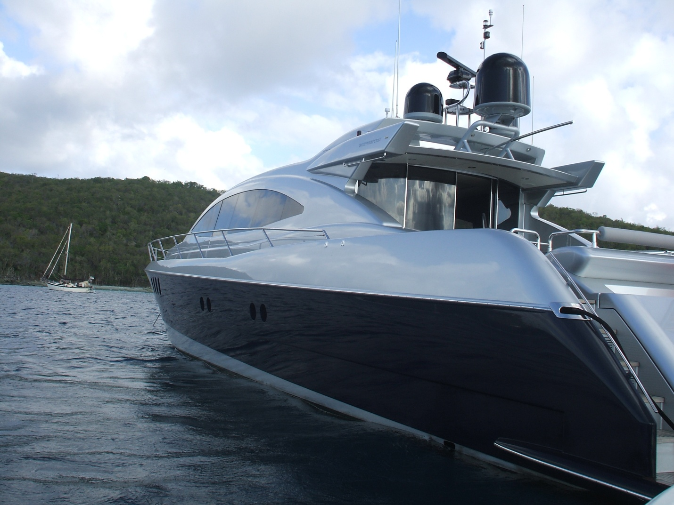

We had dinner at the Grand Cru which offered a most impressive Osso Bucco and a fine selection of wines.

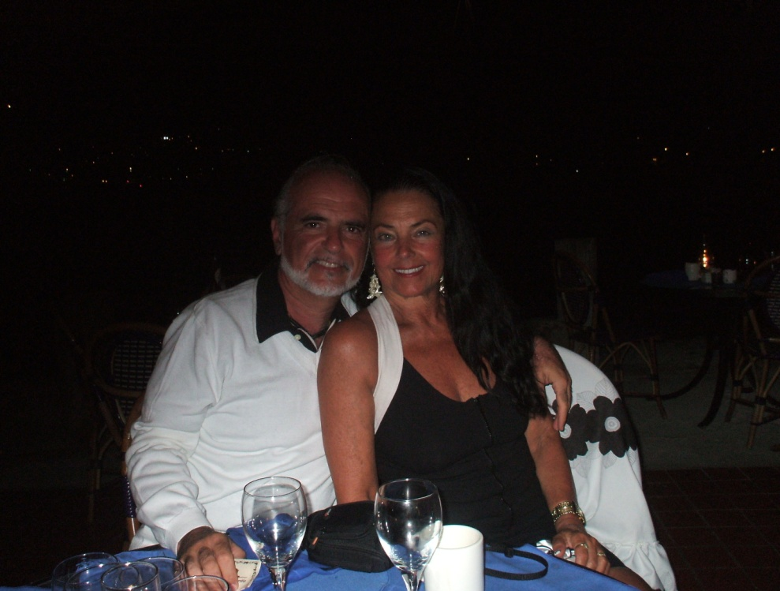

Our trip back home was routine, but the memory of this trip was anything but. This was truly an adventure in intimacy travel!

