Intimacy Among Half a Million People
The Restoring Honor Rally in Washington, D.C.
August 28, 2010

by
Kita and Gary de Sesa

IntimacyTravel.com is usually about finding intimacy through seclusion – skirting crowds, tourist traps, hotels that attract tour busses and finding “the road less traveled.”

But on August 28, 2010 we experienced a unique type of intimacy as we attended the Restoring Honor Rally in Washington, D.C. This was a non-political, non-partisan rally that paid tribute to America’s service personnel, in particular, the Special Operations Warrior Foundation, and other upstanding citizens who embody our nation’s founding principles of integrity, truth and honor. Half a million people came to celebrate America by honoring our heroes, our heritage and our future.

We hired a luxury motor coach bus from Uniworld Tours and took twenty people from Long Island to Washington, D.C. We left at 3:15 in the morning and arrived around 5 five hours later.
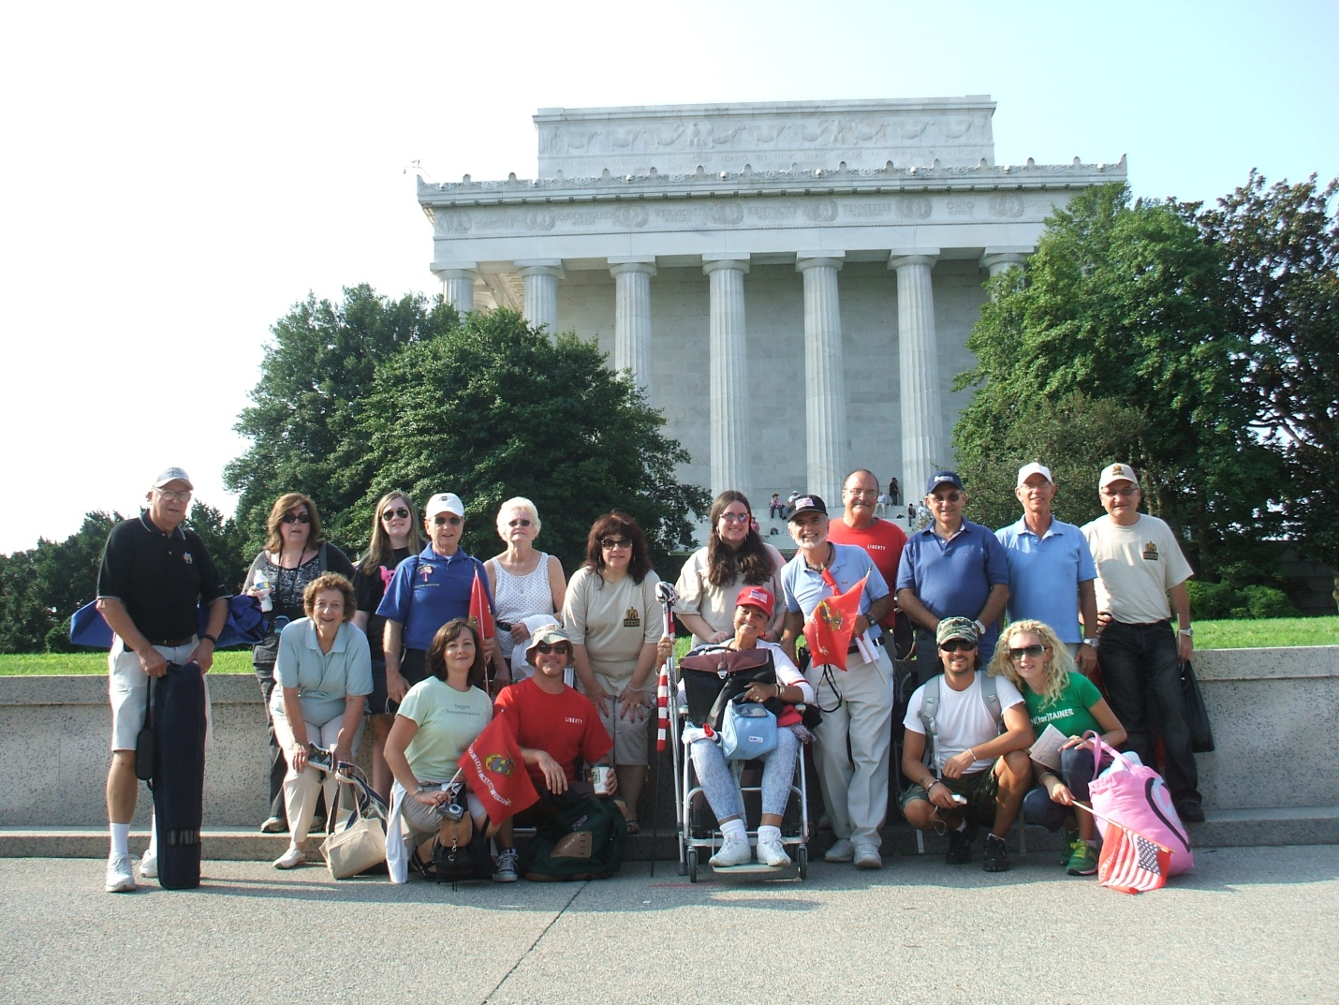

We just can't even begin to tell you the magnificence and awesome sight and presence of this American gathering. We have never been among so many people in our life and may never be again in our life time -- people from Michigan, Hawaii, California, Florida -- just all over the country, who came together for this truly inspirational event. Every conceivable demographic was represented -- entire families came with young children, young adults, the middle aged and the elderly; the firm and the handicapped. People of all races and religions gathered together for this event.

The rally didn’t start until 10am and when we arrived sometime after 8am, the area was packed. Busses were arriving by the thousands for all over the country. The Washington D.C. Metro, which we needed to take to the rally from the bus parking area, which so crowded that Metro workers said that they have never seen anything like it. We were packed into the Metro cars like sardines. When we finally arrived at the Lincoln Memorial, where the rally was to be held, there were people all ready occupying every space from the Lincoln Memorial to the Washington Memorial, which is eight-tenths of a mile long. And people were spread out widthwise to the edge of the streets on either side. There were 500,000 people there, easily. Any news reports to the contrary were just plain inaccurate. The relatively “thin” area directly around the reflecting pool alone holds 200,000 people. Even the planners were overwhelmed with the amount of people--so much so that they couldn't provide enough sound and screens for everyone to see. But people were gratified just to be part of it.

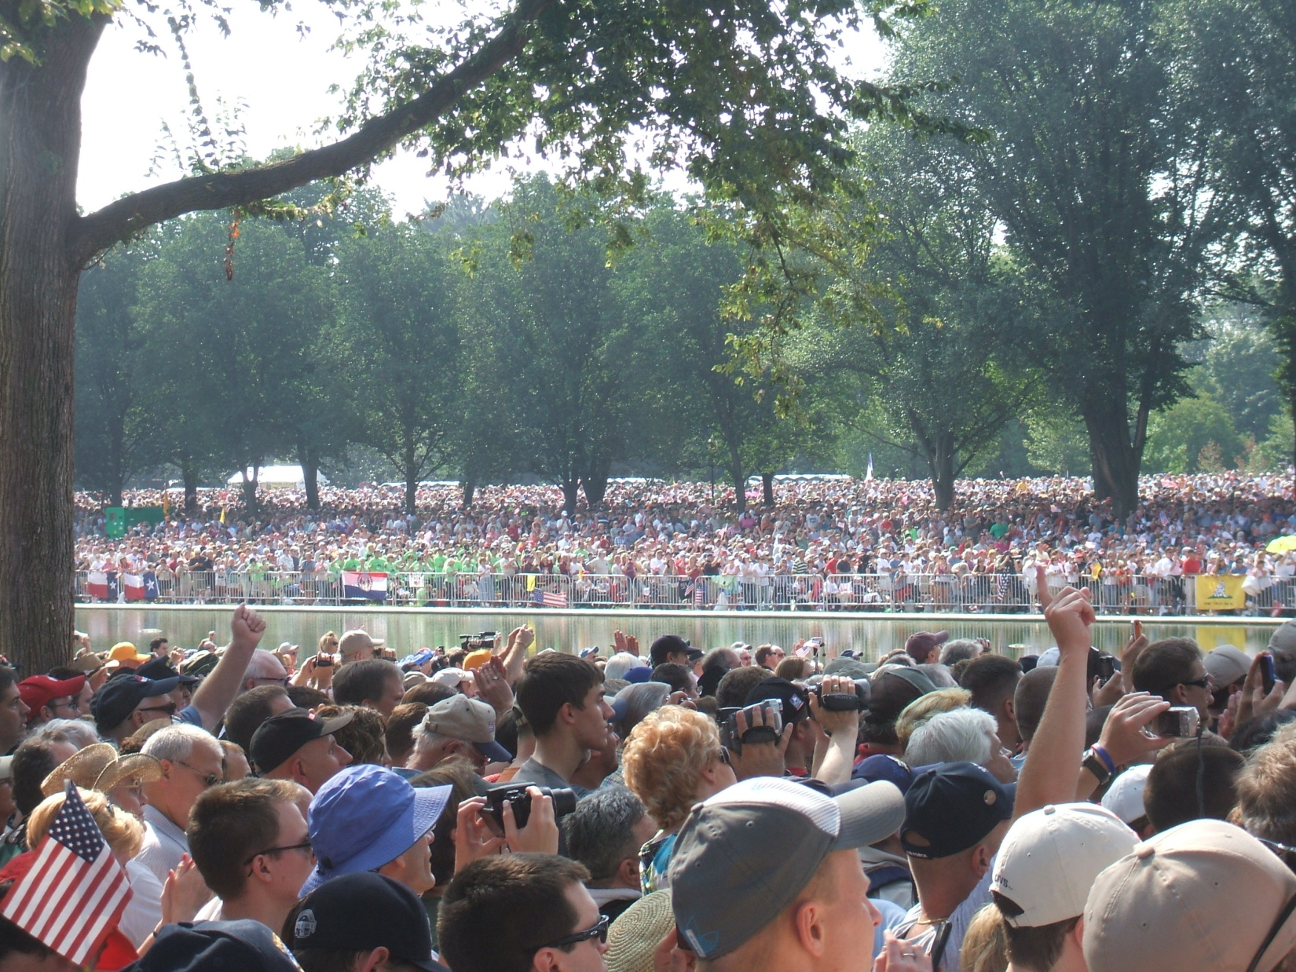

So how could this have possibly been an intimate experience? Amazingly enough, it was! Why? Because everyone who came shared a common decency, a common love of country and their fellow countrymen – and it was noticeable and you could feel it and sense it all around you.

Everyone was patient, kind and gracious to one another. There was no pushing, no yelling, no negative attitude. There was no race, religious or age distinction. Total strangers instantly felt like extended family. Whites, Blacks, Asians, Indians, young and old, all helping each other and in particular, helping those who were handicapped. We had a wheelchair-bound person in our group so we experienced this first hand. Washington is broken in more ways than one. Some of the elevators in the Metro were out of service and we were forced to use the steep and long escalators. Of course we had to stop at the escalator with the wheel chair and our wheelchair bound person had to get out of the chair and be helped to stand on the escalator steps. No sooner did she get up off the chair, then a few strapping young men came over and offered to carry the wheelchair up the steep steps, which they did. When we got to the top, they unfolded the chair, secured it and helped our passenger safely back into her wheelchair. On the Metro, while I held the chair from behind to prevent it from moving backward, a complete stranger voluntarily stood by the chair the entire trip and kept his foot in front of the wheels and his hand on the chair to prevent a sudden forward movement due to the motion of the train. Because of the volume of people, the escalators’ motion was turned off to minimize any unforeseen injury due to its automatic motion. The walk back from the Memorial was uphill and people would just come by and help me push to ease my burden and provide a smooth ride for my passenger. It was people helping people; it was friendship; it was brotherhood. What a beautiful and outstanding experience it was to be among so many of your fellow Americans. It was an honor and a privilege to be in their company! You might have seen some edited clips on TV of this event. Nothing other than being there live could possibly do it justice. Our 29 year old son, who is single and came along to help out and support our efforts, was unexpectedly overwhelmed by the sheer magnitude of the crowd and of its positive human energy and spirit. He summed it up perfectly when he said "this is something you will never forget; something you tell your kids and grandkids about."
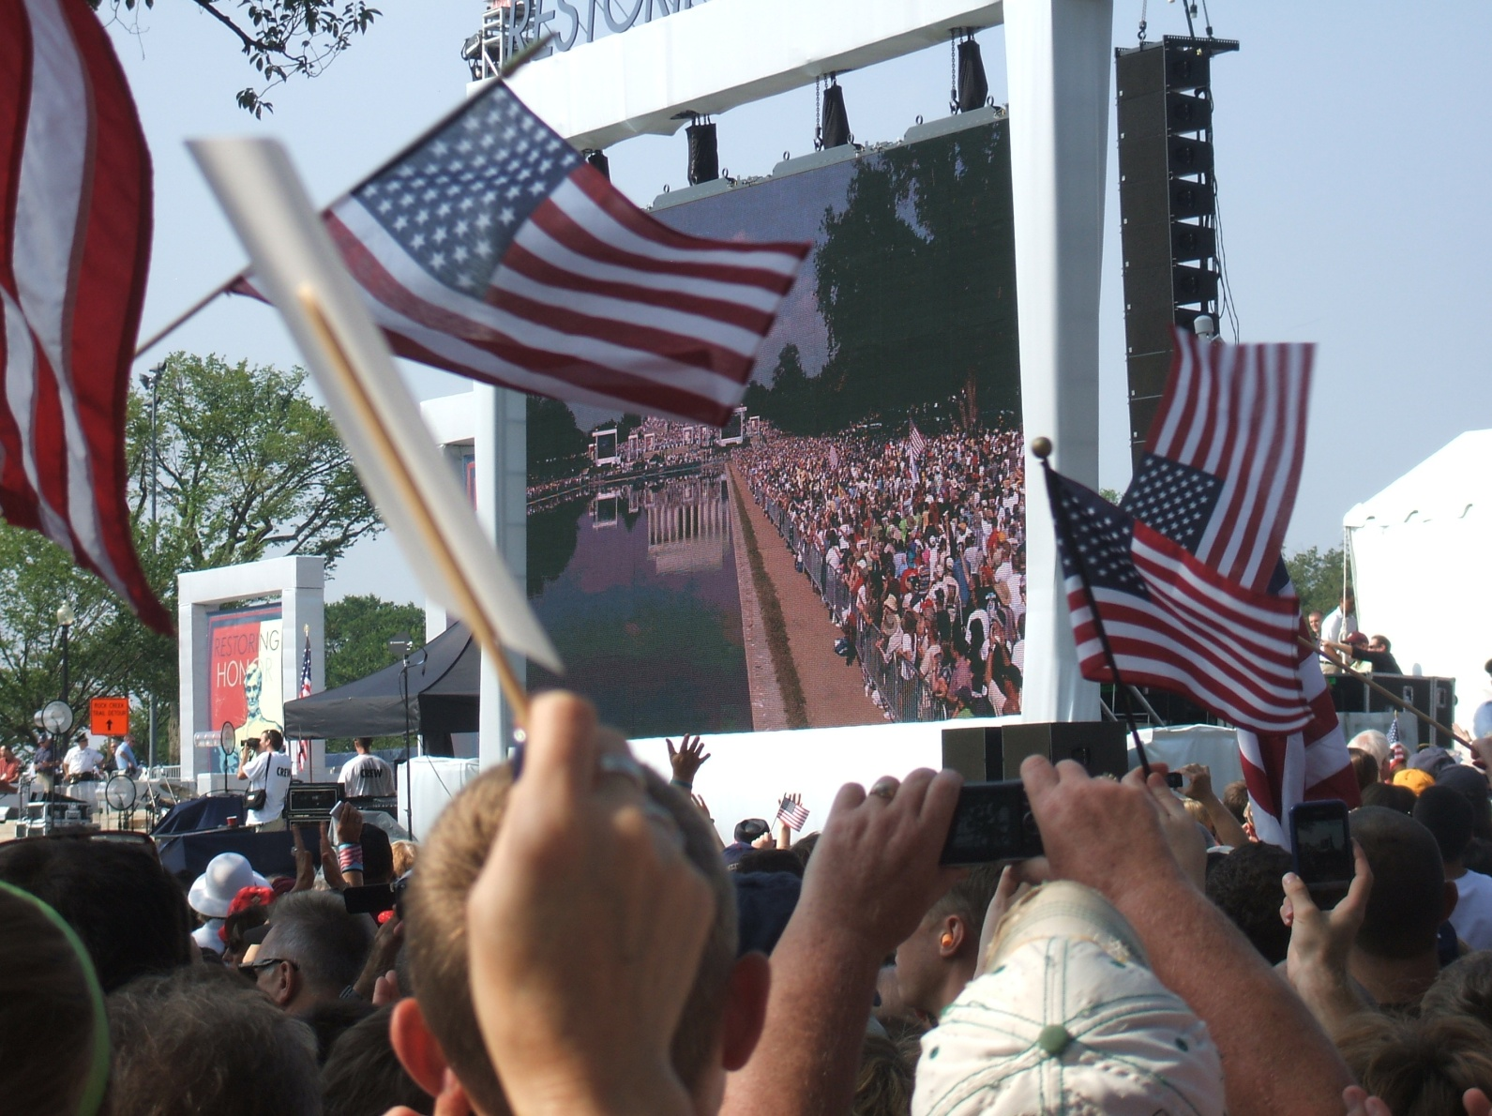

Honorable Footnote: The police reported that there was not a single arrest or incident during this entire rally and that there was no garbage to be found on the entire grounds. In fact, it was left in better condition than before the rally.

Generous Footnote: There was no entrance fee to the rally, but at one point it was announced that anyone who wanted to send a $10 donation to the Special Operations Warrior Foundation (SOWF), could do so by texting SOWF to 8594 on their phone. They raised 5 million dollars. Makes sense: $10 times 500,000 -- $5,000,000 (five million.)

